|  |
| --- |
| Golf Score Database |
|  |
| June 19th, 2021  Syracuse University  IST 659  Noah Laraway |

Table of Contents

* Summary (page 2)
* Stake Holders (page 2)
* Business Rules (page 2)
* Glossary (page 3)
* Data Questions (page 3)
* Conceptual Model (page 4)
* Logical Model (page 5)
* DDL Commands to CREATE Tables (page 6)
* DML INSERT Statements (page 7)
* SELECT Statements (page 9)
* Views (12)
* Screenshots from Jupyter Notebook/Python Connection to SQL and Analysis (page 13)
* Potential Mock Up of UI (page15
* Reflection of the Database Process (page 16)

Summary

As an avid golf fan and player, I have been trying to get better at the game and decrease my score over the years. I’ve played on many different courses and with many different people. I play with family members, friends and a lot of times both. I’ve kept scorecards, used golf score apps and have a large amount of data to look at for my golf outings. For this project I want to create a database to help me keep track and ultimately find out how much my golf game has improved over time. I also want to see what factors might impact my golf game including the course and who I play with.

Stake Holders

Due to this being a personal project, I am the main stakeholder and will be in control of the database. Other players in the database might also be interested in reviewing the data.

Business Rules

* Each player has a first and last name.
* Each golf score has a player and outing.
* Each golf outing has at least one player, course and score.
* A player can be entered into the database without having a golf outing or score to allow for future players to be put into the database, but may have many golf outings and scores.
* Each course is not required to have a golf outing associated with them to allow for future courses to be put into the database, but may have many golf outings.
* A golf outing that is cut short due to rain or any other reason will not be added to the database.

Glossary

* A player is someone who has or will be play a round of golf in the database.
* A golf course is a location where a golf outing can occur.
* Golf outing is an event where one or many players will play at a particular course.
* Each score is for a specific individual and golf outing.
* Golf course ratings are from the USGA website and can be found here: [Golf Course Ratings](https://ncrdb.usga.org/).
* A sub-course is the specific set of holes of each golf course (i.e. front-nine, back-nine, etc.).
* Number of holes is for the sub-course that is played and not necessarily the entire golf course.

Data Questions

* Has my golf game changed over time and how?
* How much does the course impact my score?
* Does golfing with specific players have an impact on my score?
* Does my score change depending on what time of year I’m playing?
* Does my score change if I play more holes in one day (i.e. 9 vs. 18)?

Conceptual Model

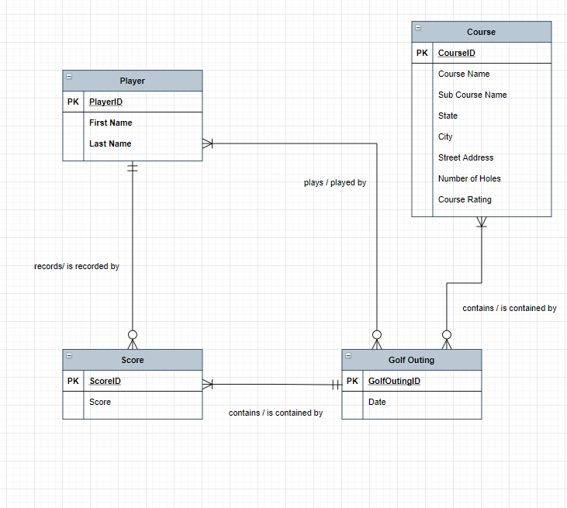

Logical Model

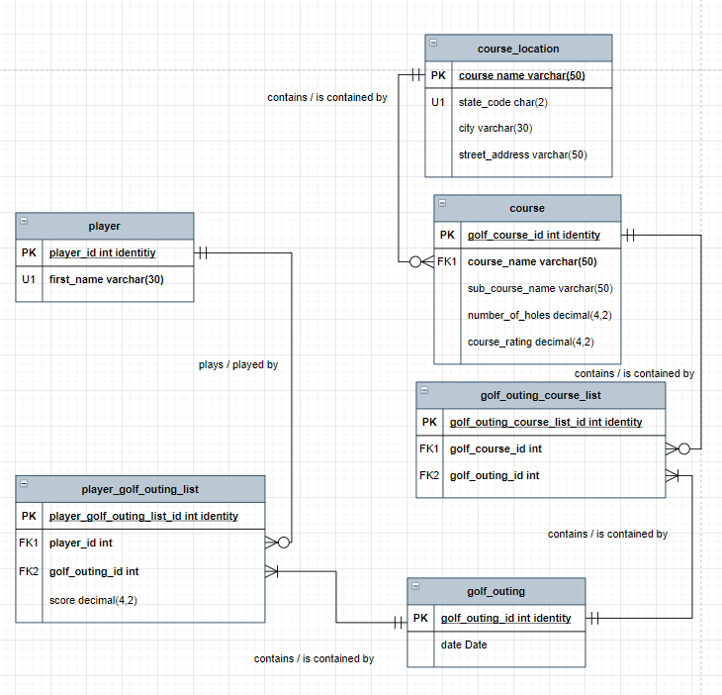

** Changes to logical model made for part 2 of project**

* Removed last name from player table to keep the players anonymous.
* Made first name in player table unique
* Moved player score from score table to player golf outing list table. After doing this the score table was removed since it was not necessary.
* Changed state in course location table to state_code char(2) for state abbreviation.
* Added unique constraint to course name in course location table.
* Change course rating and number of holes in course table and score in player golf outing list table to decimal (4,2) to allow for better accuracy with aggregate functions.

DDL Commands to CREATE Tables

--Create player table

CREATE TABLE player (

--Add columns for table

player_id int identity,

first_name varchar(30) not null,

--Add constraints

CONSTRAINT PK_player PRIMARY KEY (player_id),

CONSTRAINT U1_player UNIQUE(first_name)

)

--End create player table

--Create golf_outing table

CREATE TABLE golf_outing (

--Add columns for table

golf_outing_id int identity,

date Date,

--Add constraints

CONSTRAINT golf_outing_id PRIMARY KEY (golf_outing_id),

)

--End create golf_outing table

--Create course_location table

CREATE TABLE course_location (

--Add columns for table

course_name varchar(50),

state_code char(2),

city varchar(30),

street_address varchar(50),

--Add constraints

CONSTRAINT PK_course_location PRIMARY KEY (course_name),

CONSTRAINT U1_course_location UNIQUE(course_name)

)

--End create course_location table

--Create course table

CREATE TABLE course (

--Add columns for table

golf_course_id int identity,

course_name varchar(50) not null,

sub_course_name varchar(50),

number_of_holes decimal(4,2),

course_rating decimal(4,2),

--Add constraints

CONSTRAINT PK_course PRIMARY KEY (golf_course_id),

CONSTRAINT FK1_course FOREIGN KEY(course_name) REFERENCES course_location(course_name)

)

--End create course table

--Create golf_outing_course_list table

CREATE TABLE golf_outing_course_list (

--Add columns for table

golf_outing_course_list_id int identity,

golf_course_id int not null,

golf_outing_id int not null,

--Add constraints

CONSTRAINT PK_golf_outing_course_list PRIMARY KEY (golf_outing_course_list_id),

CONSTRAINT FK1_golf_outing_course_list FOREIGN KEY(golf_course_id) REFERENCES course(golf_course_id),

CONSTRAINT FK2_golf_outing_course_list FOREIGN KEY(golf_outing_id) REFERENCES golf_outing(golf_outing_id)

)

--End create golf_outing_course_list table

--Create player_golf_outing_list table

CREATE TABLE player_golf_outing_list (

--Add columns for table

player_golf_outing_list_id int identity,

player_id int not null,

golf_outing_id int not null,

score decimal(4,2)

--Add constraints

CONSTRAINT PK_player_golf_outing_list PRIMARY KEY (player_golf_outing_list_id),

CONSTRAINT FK1_player_golf_outing_list FOREIGN KEY(player_id) REFERENCES player(player_id),

CONSTRAINT FK2_player_golf_outing_list FOREIGN KEY(golf_outing_id) REFERENCES golf_outing(golf_outing_id)

)

--End create player_golf_outing_list table

DML INSERT Statements

--Add rows into player table

INSERT INTO player (first_name)

VALUES('Noah'),('Jon'),('Travis'),('Randy'),('Steve'),('Gary')

SELECT * FROM player

--Add rows into course_location table

INSERT INTO course_location (course_name, state_code, city, street_address)

VALUES

('Sunset', 'CO', 'Longmont', '1900 Longs Peak Ave'),

('Ute Creek', 'CO', 'Longmont', '2000 Ute Creek Dr'),

('Twin Peaks', 'CO', 'Longmont', '1200 Cornell Dr'),

('Legacy Ridge', 'CO', 'Westminster', '10801 Legacy Ridge Pkwy'),

('Broadlands', 'CO', 'Broomfield', '4380 West 144th Ave.'),

('Willis Case', 'CO', 'Denver', '4999 Vrain St')

SELECT * FROM course_location

--Add rows into golf_outing table

INSERT INTO golf_outing (date)

VALUES ('2019-04-12'),('2019-04-28'),('2019-05-19'),('2019-06-03'),('2019-06-14'),('2019-06-26'),('2019-07-10'),

('2019-07-25'),('2019-08-05'),('2019-08-12'),('2019-08-16'),('2019-09-01'),('2019-09-22'),('2019-10-01'),

('2020-07-07'),('2020-07-12'),('2020-07-23'),('2020-08-05'),('2020-08-19'),('2020-08-30'),('2020-09-10'),

('2020-09-22'),('2021-04-29'),('2021-05-03'),('2021-05-17')

SELECT * FROM golf_outing

--Add rows into course table

INSERT INTO course (course_name, sub_course_name, number_of_holes, course_rating)

VALUES ('Sunset', 'Front 9', 9, 33.2),('Sunset', 'Back 9', 9, 33.8),('Sunset', 'All 18', 18, 67),

('Ute Creek', 'Front 9', 9, 34.2),('Ute Creek', 'Back 9', 9, 33.4),('Ute Creek', 'All 18', 18, 67.6),

('Twin Peaks', 'Front 9', 9, 34.6),('Twin Peaks', 'Back 9', 9, 35.1),('Twin Peaks', 'All 18', 18, 69.7),

('Legacy Ridge', 'Front 9', 9, 32.8),('Legacy Ridge', 'Back 9', 9, 32.3),('Legacy Ridge', 'All 18', 18, 65.1),

('Broadlands', 'Front 9', 9, 33),('Broadlands', 'Back 9', 9, 33.6),('Broadlands', 'All 18', 18, 67.2),

('Willis Case', 'Front 9', 9, 35),('Willis Case', 'Back 9', 9, 32.7),('Willis Case', 'All 18', 18, 67.7)

SELECT * FROM course

--Add rows into player_golf_outing_list

INSERT INTO player_golf_outing_list (player_id, golf_outing_id, score)

VALUES (1, 1, 46), (6, 1, 45), (1, 2, 48), (2, 2, 41), (1, 3, 89), (4, 3, 92), (2, 3, 95), (6, 3, 87), (1, 4, 46),

(4, 4, 47), (1, 5, 92), (2, 5, 96), (3, 5, 88), (5, 5, 92), (1, 6, 89), (6, 6, 97), (2, 6, 89), (5, 6, 88),

(1, 7, 47), (3, 7, 45), (1, 8, 45), (5, 8, 56), (1, 9, 45), (6, 9, 44), (2, 9, 42), (4, 9, 45), (1, 10, 43),

(3, 10, 41), (5, 10, 45), (1, 11, 85), (2, 11, 85), (3, 11, 88), (6, 11, 92), (1, 12, 43), (6, 12, 43), (1, 13, 42),

(5, 13, 40), (1, 14, 84), (3, 14, 86), (1, 15, 49), (3, 15, 50), (1, 16, 46), (6, 16, 47), (1, 17, 95), (2, 17, 95),

(5, 17, 93), (3, 17, 91), (1, 18, 88), (5, 18, 89), (3, 18, 94), (4, 18, 97), (1, 19, 45), (2, 19, 45), (1, 20, 43),

(6, 20, 42), (1, 21, 44), (5, 21, 40), (1, 22, 85), (3, 22, 89), (6, 22, 91), (2, 22, 83), (1, 23, 49), (6, 23, 46),

(1, 24, 95), (4, 24, 92), (6, 24, 94), (5, 24, 90), (1, 25, 48), (3, 25, 43)

SELECT * FROM player_golf_outing_list

--Add rows into golf_outing_course_list

INSERT INTO golf_outing_course_list (golf_course_id, golf_outing_id)

VALUES (10, 1), (7, 2), (18, 3), (13, 4), (3, 5), (6, 6), (7, 7), (7, 8), (10, 9), (4, 10), (12, 11),

(14, 12), (13, 13), (6, 14), (7, 15), (8, 16), (18, 17), (3, 18), (8, 19), (14, 20), (17, 21), (12, 22),

(13, 23), (3, 24), (17, 25)

SELECT * FROM golf_outing_course_list

SELECT Statements

Has my golf game changed over time (year over year)?

Based on this data it appears my golf score has changed over time, but not for the better!

How much does the course impact my score?

It does look like courses can have an impact on my golf score. Willis Case appears to be the toughest course and Ute Creek the easiest course. The differential between playing at these two courses has been about 7 strokes on average over 18 holes.

Does golfing with specific players have an impact on my score? (first screenshot is for one for player)

The below screenshots have the same code at the top as the screenshot above and only the show the code that was adjusted for each specific player.

It does not look like there is much variance in my score depending on who I was playing with. I played the best with Steve and the worst with Randy, but it was only about 1.7 strokes difference per 18 holes .

Does my score change depending on what time of year I am playing?

My scores appear to improve as each golf season progresses. April is the worst month and October is the best the month.

Does my score change if I play more holes in one day (i.e. 9 vs. 18)?

The number of holes played only has a slight impact on my overall score. When playing 18 holes instead of 9 my score is about 1.4 strokes lower.

Views

View for my Top 5 Scores

View for my Last 5 Rounds of Golf

Screenshots from Jupyter Notebook/Python

Connect to database and pull in course table data to check connection is working

Has my golf game changed over time (year over year)?

How much does the course impact my score?

Does golfing with specific players have an impact on my score?

Does my score change depending on what time of year I am playing?

Does my score change if I play more holes in one day (i.e. 9 vs. 18)?

Potential Mock Up of UI/UX

Next step is to be able to pull the data into a website and be able to filter by player, course and date using PowerBI or Tableau. I need more experience with those programs, but it would look something similar to this:

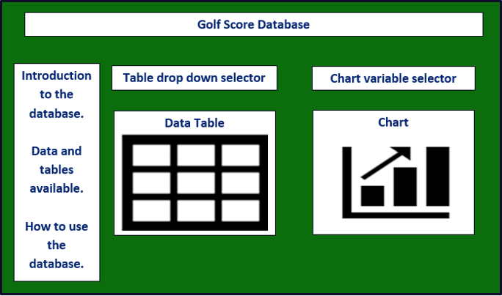

Reflection of the Database Process

Overall, the project was extremely helpful in understanding how the database process works. The main takeaway for me is that preplanning is very important before entering data. There were several issues that came up when I was trying to analyze the data and I needed to go back and make adjustments to the tables.

When making the diagrams it’s necessary to get a good understanding of how the tables will relate to one another. I originally had an extra table in project 1 that was not necessary. I was able to remove that table and put the data into another table that essentially was the same except for one column. This reduced the number of tables, but also reduced the additional coding/time needed to create and use it.

Also, knowing what datatypes are needed and how to relate the tables beforehand can save a lot of time down the road. I initially had certain columns as integers, but needed to change them to decimals so that aggregate functions could be performed correctly with more accurate results. This caused me to need to go back and recreate the tables and adjust the datatypes. This took extra time that could have been avoided with better pre-planning.

After taking this class I have a much better understanding of databases in general and the thought process that goes into creating them. Going forward I will make sure to spend more time up front focusing on the overall needs from the end users and how the tables will be used instead of rushing to start coding the database.